**ALAGAPPA COLLEGE OF TECHNOLOGY**

**ANNA UNIVERSITY-600025**

**Project type:**

To embed a Google Analytics Code on our Website

**Project name:**

**HYDRING**

**Department:**

B.Tech-Pharmaceutical technology

**Team Details:**

|  |  |  |
| --- | --- | --- |
| **Student Name** | **Roll no.** | **Naan mudhalvan ID** |
| Balamurugan K | 2020308004 | C095ED2AD7A87D9A79A4876FDA05737C |
| Gowtham Kumar G | 2020308009 | F8244370540AC0A97B64D20DA11BA7D2 |
| Harikrishnan P | 2020308012 | 9EA160F73AB7865BD034059407CA0721 |
| Mohamed Natheem A | 2020308022 | 69F644195C4638489AA473B2986ADCAB |
| Gowtham R | 2020308010 | 204A63937B086B2A80347E80A78A34A7 |

--------------------------------------------------------------

**Brand Name:** HYDRING

**Category:**Food & Drink

**Email:** [hydringbeverages@gmail.com](mailto:hydringbeverages@gmail.com)

**Blog address:** <https://hydringbeverages.blogspot.com/>

**GitHub link :** <https://github.com/mahtwog2002/mahtwog2002>

**Google analytics tracking code:** G-QL07RGX7RC

**Aim :**

To embed a Google Analytics Code on our Website

**Purpose :**

By implementing Google Analytics, Hydring can

Make Data-Driven Decisions. We have seen how analytics empowers us to make informed choices, leading to more effective marketing campaigns, better content, and improved user experiences.

Gain Real-time Insights: The ability to monitor our website’s performance in real-time gives us a competitive edge. We can react promptly to any changes, ensuring our online presence stays relevant and impactful.

Customize for Our Needs. Google Analytics is highly flexible, allowing us to customize our tracking and reporting to meet Hydring’s specific requirements. We have the tools to track what matters most to our company.

**Procedure:**

* Sign up for a Google Analytics account.
* After signing in, create a new property for your website within your Google Analytics account.
* Copy the measurement ID from web stream details page
* Update the ID in your blog settings
* After adding the measurement ID, go back to your Google Analytics account and click “Tracking Info” again. You should see a status that says “Receiving Data.”
* It may take some time for Google Analytics to start collecting and displaying data.

**Result :** We have embedded the Google analytics code on our website

**Advantages:**

* Data-Driven Decisions: How it helps in making informed decisions.
* Real-time Tracking: Instant insights into website performance.
* customization: Tailoring analytics to Hydring’s specific needs.
* Audience Insights: Understanding
* Customer demographics and behavior.

**Disadvantages:**

* 01 Data Overload: Too much data can be overwhelming.
* 02 Data Privacy Concerns Privacy issues related to tracking user data.
* Learning Curve: Can be complex for beginners.

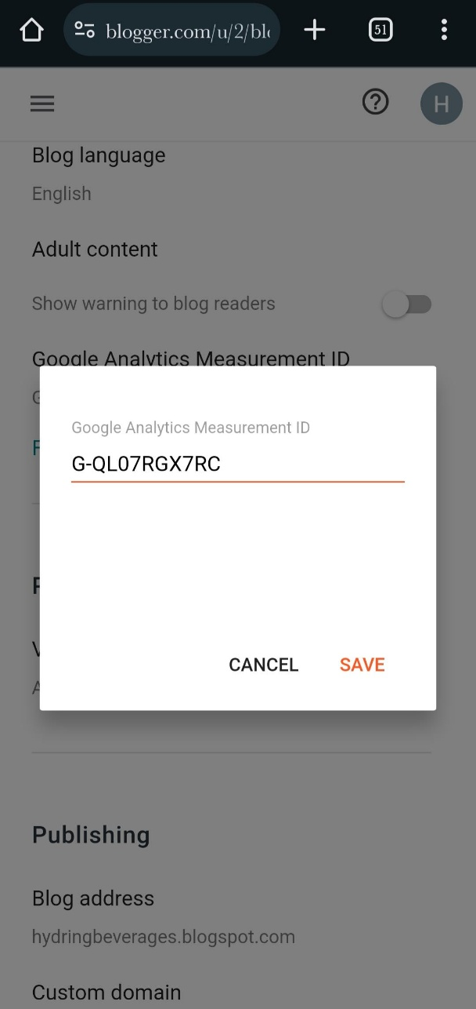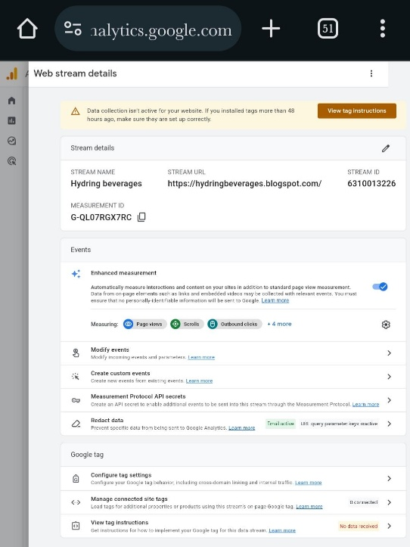**Map:**